# Proposal Project 2

## Technical

**Python Flask powered API which includes creation of API endpoints:**

Use Python Flask to get API for weather articles and put into PostgreSQL database.

**HTML/ CSS, Javascript website:**

Option B:

* Home page - UV
* Temperature
* About page

**Use at least one new JS library:**

* Top map: D3 contour (<https://github.com/d3/d3-contour>)



* ?Middle: Bar or line graph showing average of last 5 years for one year?
* History visual: Nivo calendar (<https://nivo.rocks/calendar>) – last year

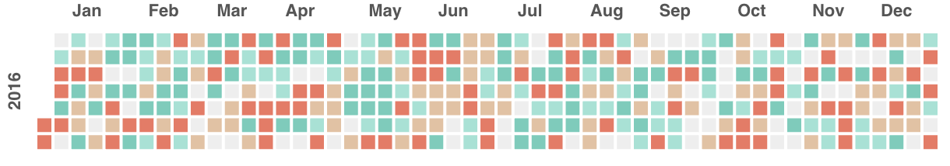

**Dataset with at least 100 records:**

Weather data for WA will contain more than 100 records. We have different locations and DateTime.

**Use user-driven interaction:**

Search box & menu with home and about pages

**Include at least 3 views:**

1. Index page - UV
2. 2nd page - Temperature
3. 3rd page - About page

## Work flow chart

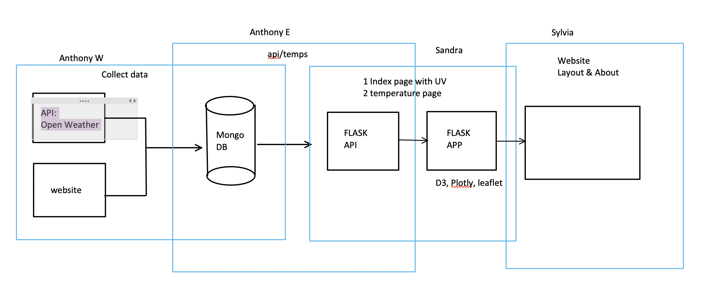

## Sketch page layout

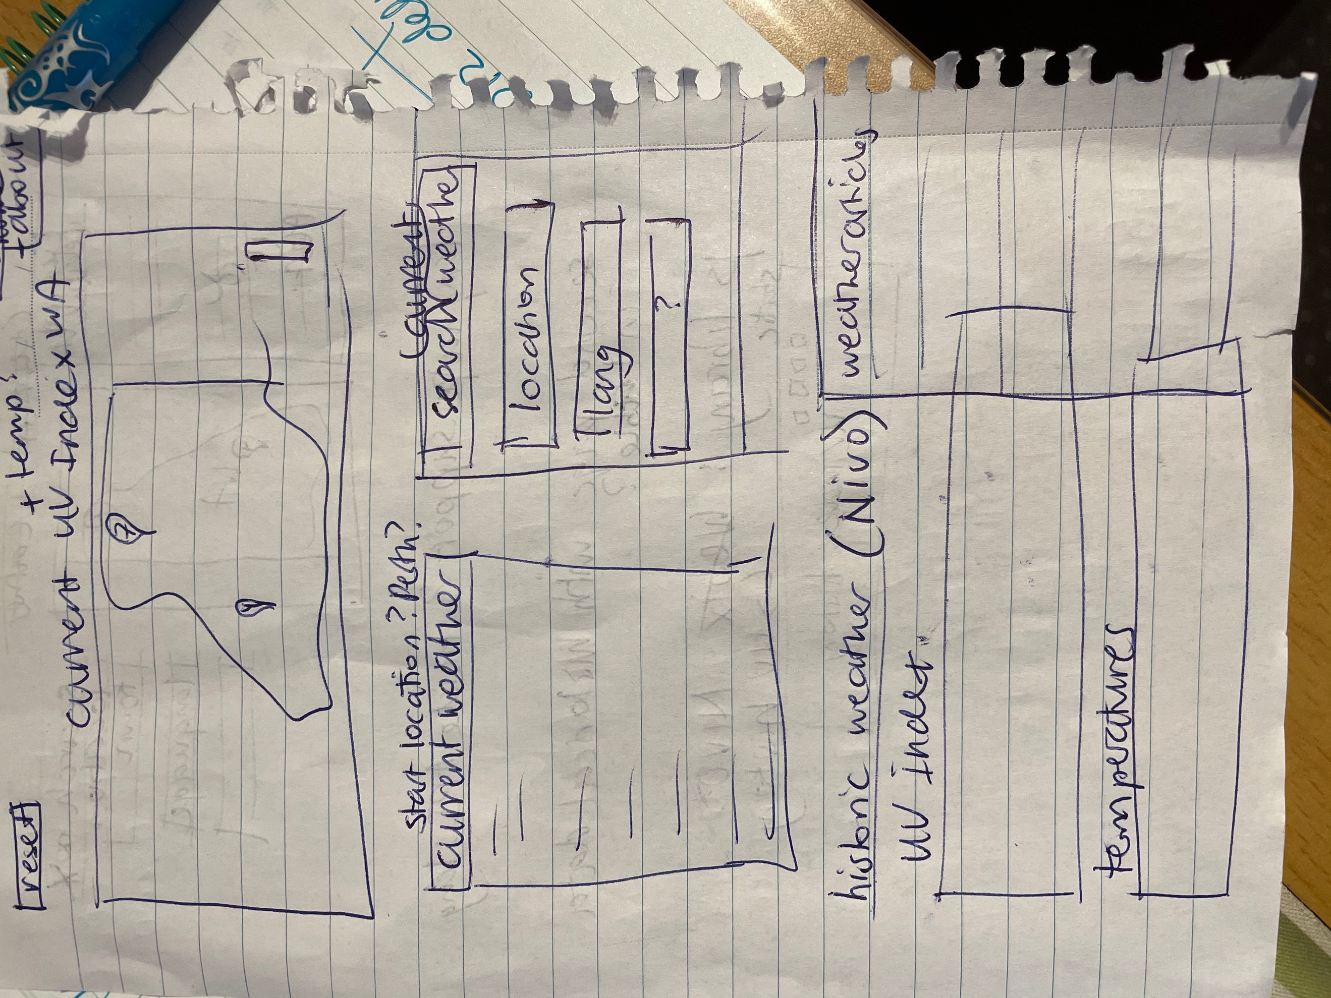

## Presentation

**Subject**: Provide UV index and temperature information for WA

**Questions**:

1. Has the UV index increased over time?
2. Does the temperature affect the UV rating?

**Data**:

Searched for Weather API’s. There are a few options but they are mostly paid or free for only a month. We chose OpenWeathermap as it is free and has the UV rating and temperatures available.

**Conclusions**:

**Implications**:

**Tell a good Story**: